**C:\Users\user\Downloads\College Logo (Grey).tif** 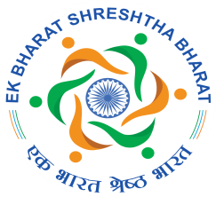

**PERUNTHALAIVAR KAMARAJAR ARTS COLLEGE**

(An Institution functioning under the aegis of Pondicherry Society for Higher Education)

**KALITHEERTHALKUPPAM, PUDUCHERRY-605 107.**

**REPORT OF EK BHARAT SHRESHTHA BHARAT**

**CLUB INAUGURATION**

**3rd December 2019**

**Head of the Institution: Dr. S. Babu**

**Nodal Officer: Dr. V. Indira**

The Ek Bharat Shreshta Bharat Scheme was initiated in the U.T. of Puducherry as per the instruction of the NITI Aayog by means of signing a MoU with the U.T. of Daman and Diu on the 31st October 2016, in the presence of the Honorable Prime Minister. The proposal was to conduct various cultural events , film festival, exchange programmes ,competitions etc.

**INAUGURATION OF EBSB CLUB**

As per the direction of MHRD, GOI, to have Nodal Officer for the institution Dr. V. Indira, Assistant Professor, Dept. of Mathematics, was appointed as the Nodal Officer for Perunthalaivar Kamarajar Arts College.

Perunthalaivar Kamarajar Arts College, Kalitheerthalkuppam, Puducherry inaugurated the EBSB club in its premises on 3rd December 2019 at 2:30 P.M... The principal Dr. S. Babu, delivered the inaugural address and gave a thorough insight about the programme. Dr. Jayamarie Sujatha Tamby, Asst. Professor of French welcomed the gathering and Dr. V. Indira explained the objective of the programme and proposed vote of thanks.

Around 120 students and 30 staff members were present in the event. Out of which, the Principal and eighteen staff members joined as members of the EBSB club. The students were also advised to become members of the club.

**PHOTOS**

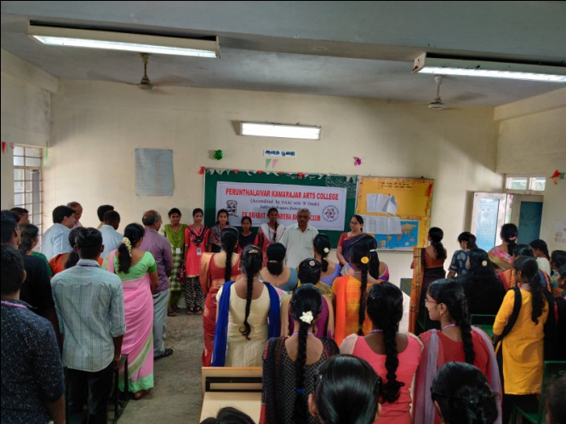

**Invocation by girls followed by inauguration of EBSB club**

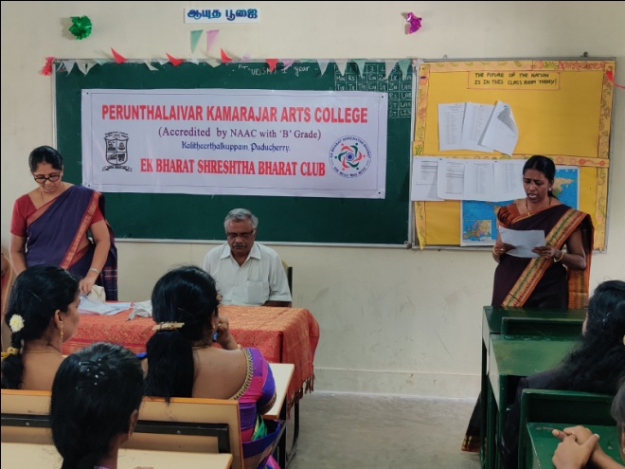

**Welcome Address by Dr. Jayamarie Sujatha Tamby**

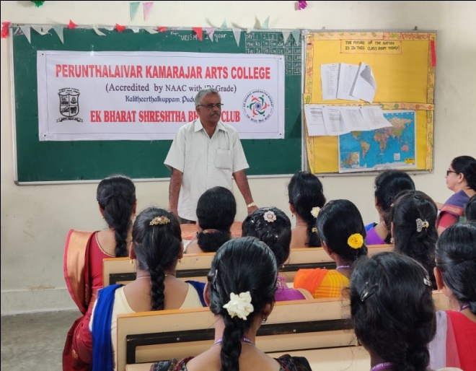

**Inaugural address by the Principal**

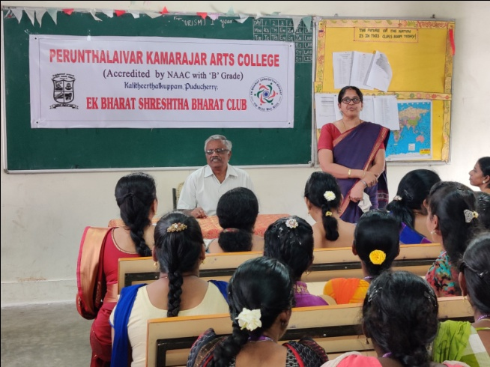

**Briefing the action plan of EBSB club and vote of thanks by**

**Dr. V. Indira – Nodal officer, EBSB**

